Unit: Soldiers

Lesson 1.11: Weapons of War  The Monitor

Aim: To learn about the shipbuilding industry in 19th-century Brooklyn, as well as the history and significance of the first ironclads.

Objective: Students read about the shipbuilding industry in Brooklyn and listen to a related picture book while taking notes. They also compare and contrast two historic battleships from the era and compose a letter or journal entry incorporating their new knowledge.

Materials:
- Images of the Monitor on overhead:
- Diagram of the Monitor from Harper’s http://www.brooklynpubliclibrary.org/civilwar/cwdoc034.html
- Illustration of the battle http://www.brooklynpubliclibrary.org/civilwar/cwdoc035.html
- Postcard with color illustration of the battle http://www.brooklynpubliclibrary.org/civilwar/cwdoc036.html
- Photograph of sailors on deck of the Monitor http://www.brooklynpubliclibrary.org/civilwar/cwdoc037.html
- Shared reading
- Duel of the Ironclads: The Monitor Vs. the Virginia by Patrick O’Brien (Walker & Company, 2003)

Procedure:
- Show images of the Monitor on overhead or reproduce for small groups.

- Students record observations on folded loose-leaf paper (I see…, I think…).

- Shared reading on overhead about the shipbuilding industry in Brooklyn during the Civil War era.

A note about shared reading: During a shared reading session, the whole class is on the same “page”—everyone’s attention is focused on the same overhead transparency. The teacher models the initial reading in several ways. In addition to simply reading the passage aloud, slowly and clearly, he or she reveals thoughts and reading strategies for the group. Be it visualizing, making connections, or noticing new or interesting vocabulary, these thoughts are shared so that students see and understand what goes on in the mind of a good reader.

- Read aloud from Patrick O’Brien’s Duel of the Ironclads: The Monitor Vs. the Virginia (Walker & Company, 2003).

- Students are instructed to take notes during the reading, after which they attempt to answer the following questions:
- What was the purpose of adding iron to traditional wooden ships?
- Describe some of the earliest ironclads. Where were they built?
- At first, what did people think of the Monitor?
- Who won the battle between the Monitor and the Virginia? Explain.
- What happened to the two ships in the end?

- Copy the diagrams of the two warring battleships onto an overhead. Ask students to study the two labeled pictures and create a Venn diagram (see below), enumerating the similarities and differences between the ships.

7. Writing Assignment:
Imagine you were a Union soldier assigned to the Monitor. Describe your impressions, fears, and hopes for the warship either in a letter home to your family or in a diary entry.

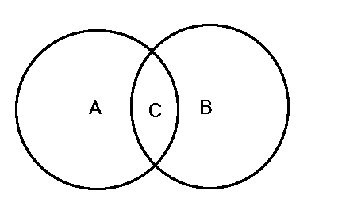

The shipbuilding industry thrived in Brooklyn during the war years. In addition to the Brooklyn Navy Yard, a second shipyard, Webb & Bells, opened in Greenpoint in 1850. By the summer of 1861, 1,650 laborers and mechanics were employed daily, busily building warships for the Union.

While today’s arms race is one for nuclear weapons, an entirely different but equally earnest race went on during the Civil War. Ironclad battleships would replace the wooden warships of the time during this period. The Monitor, one of the earliest, most innovative of these iron-clads, was built in Greenpoint after a Union spy alerted Washington about the Confederate ironclad, the Virginia (aka the Merrimack). Commissioned by President Lincoln for the Union Army in 1861, the Monitor was hurriedly built in 100 days. Swedish inventor John Ericsson, a former naval cadet and army engineer, designed the ship, which was much smaller and faster than previous vessels.

